LAB ACTIVITY 7

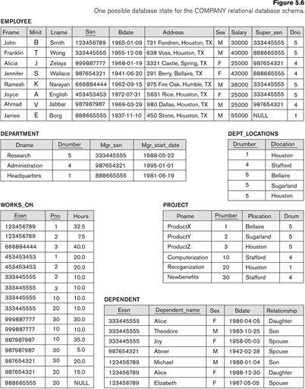

Write SQL Queries (Refer to the above given schema for answering the following queries)

1) Find the names of all employees have ‘Jennifer Wallace’ as their direct supervisor.

2) Retrieve the name of each employee who has a dependent with the same first name and same sex as the employee.

3) Retrieve the names of all employees in department 5 who work more than 10 hours per week on the Product X project.

4) For every project located in ‘Stafford’, list the project number, the controlling department number, and the department manager’s last name, address, and birth date.

5) Retrieve the name of each employee who works on all the projects controlled by department number 5.